Coordinated Audit on Protected Areas – 2019/2020
Supreme Audit Institutions (SAIs) play an important role in fostering governmental accountability and in promoting the efficiency, accountability, effectiveness and transparency of public administration, which is conducive to the achievement of national development objectives and priorities as well as the internationally agreed development goals, as recognised by the United Nations General Assembly (A/RES/66/209, 2011; A/RES/69/228, 2014). SAIs provide governments, parliaments and other stakeholders with relevant information not only through their compliance work on financial statements, but also through performance audits, which allow to assess “whether government undertakings, systems, operations, programmes, activities or organisations are operating in accordance with the principles of economy, efficiency and effectiveness and whether there is room for improvement” (ISSAI 300, 9).
In order to approach cross-border audit topics, such as environmental issues, SAIs can join efforts to conduct coordinated audits, where a group of SAIs simultaneously carry out audits according to an integrated planning approach and a common audit methodology. The core outcome of a coordinated audit is a regional panorama of the audit topic, with consolidated results, main findings and good practices, as well as the specific audit reports produced by each participating SAI regarding their respective jurisdiction. In addition, coordinated audits are valuable for building capacities, reinforcing oversight of environmental matters, strengthening cooperation amongst SAIs and other institutions, and establishing professional networks. In Latin America and the Caribbean, several coordinated audits have been conducted so far on environmental topics—such as protected areas, water resources, climate change, environmental liabilities, and preparedness to implement the 2030 Agenda—under the Special Technical Commission for the Environment (COMTEMA), which integrates the Organization of Latin American and Caribbean Supreme Audit Institutions (OLACEFS).,
As part of the work to be performed during the 2018-2020 term of office, COMTEMA, presided over by the SAI-Brazil, decided to conduct a coordinated audit on protected areas, the main objective being to assess the management of protected areas in the participating countries, and their contribution to Aichi Target 11, and to Sustainable Development Goals (SDGs) 14 and 15. Through this audit, COMTEMA seeks to carry out a systemic analysis of protected areas, to determine to what extent each country has met international targets, and to examine the integration of this public policy with other related ones. This work builds on the previous audit on protected areas, led by the SAI-Brazil and the SAI-Paraguay in 2014 and 2015, when 12 SAIs evaluated 1,120 protected areas, allowing for elaborating an unprecedented diagnostic at a regional level regarding protected areas as a central tool for conservation in situ. Moreover, in its national audit, SAI-Brazil also concluded that Brazilian protected areas in Amazon Rainforest were successful in protecting forests (deforestation outside those protected areas was 5.3 times higher than inside them from 2008 to 2012) and in mitigating climate change (from 1996 to 2006, Brazilian protected areas in Amazon removed an average of 1.9 tC/ha—tons of carbon per hectare—, whereas areas outside them released an average of 7.11 tC/ha).
This second edition of the Coordinated Audit on Protected Areas had the participation of 17 SAIs—11 of which had participated in the previous audit—, being 13 Latin-American SAIs, 2 Caribbean SAIs, and 2 European SAIs, as well as 9 subnational audit institutions (8 Brazilian state-level audit institutions, and one Argentinian provincial-level audit institution), adding up to more than 100 auditors in 26 audit teams. The coordinated audit objectives were (1) to assess the implementation and management of protected areas, and (2) to evaluate the progress of the participating countries towards Aichi Target 11 and SDG Targets 14.5, 15.1 and 15.5—considering the percentage of terrestrial, coastal and marine areas under formally established protected areas, as well as the effectiveness of their management. The audit was coordinated by SAI-Brazil and received technical and financial support of German cooperation through the Deutsche Gesellschaft für Internationale Zusammenarbeit (GIZ) GmbH, under the Project “Strengthening of external financial control in the environmental field”.
In the audit, the SAIs assessed the implementation and management of 2,415 protected areas—1,028 of which had been evaluated in the 2014 coordinated audit—, using the Index of Implementation and Management of Protected Areas (INDIMAPA), whose objectives are to evaluate the protected areas, communicate the results in a straightforward fashion, and follow up the measures taken by government to address the audit findings. This tool allows individual evaluations for each protected area, as well as systemic evaluations for the whole set of protected areas, and specific evaluations for groups of selected protected areas—for instance, using IUCN categories, national categories or other relevant classifications. INDIMAPA was developed by SAI-Brazil during the first edition of the Coordinated Audit on Protected Areas, building upon other well-known assessment tools: Rapid Assessment and Priorisation of Protected Area Management (RAPPAM), developed by the World Wide Fund for Nature (WWF); the Management Effectiveness Tracking Tool (METT), developed by the World Bank; and a set of indicators developed by the environmental agency of the state of Amazonas, Brazil.
The evaluation is made through 13 indicators regarding the main processes and inputs necessary to properly implementing and managing protected areas, namely: management plan, human resources, financial resources, infrastructure, territorial consolidation, protection, scientific research, biodiversity monitoring, management committee, sustainable use of natural resources by local and/or traditional communities, public use, concessions, and local articulation. The input data include official information provided by governmental bodies, surveys and interviews with park rangers, official reports and technical visits to protected areas. The output is an assessment of each protected area for each indicator in a scale from 0 to 3, and an average of such values for each protected area (0.00 to 3.00). Finally, the results are classified into three ranks of implementation and management: low (0 ≤ i < 1), medium (1 ≤ i < 2), and high (2 ≤ i ≤ 3).
The results are communicated in various fashions: videos, radar charts, maps showing the georeferenced location of the protected areas assessed (see Figure 1, below), two-pager, and executive summary (see Figure 2, below)—most of which have been largely used to communicate findings and consolidated results of coordinated audits in OLACEFS.
Figure 1 – INDIMAPA 2014 results for Latin American protected areas
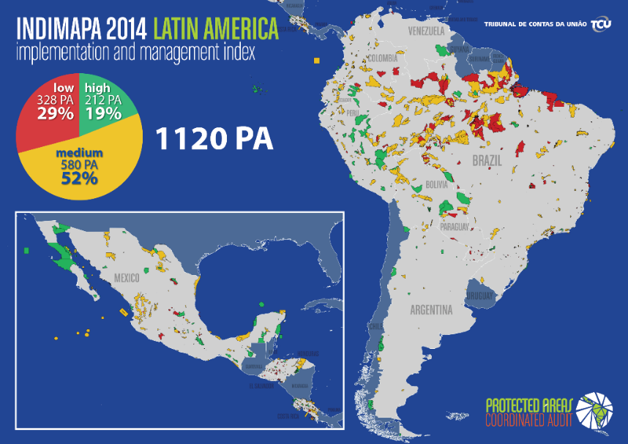
Source: TCU
Figure 2 – Executive summaries of the 2014 Coordinated Audit on Protected Areas: national and international parts
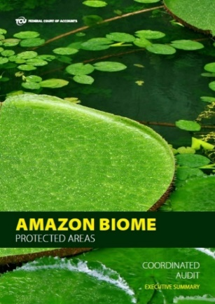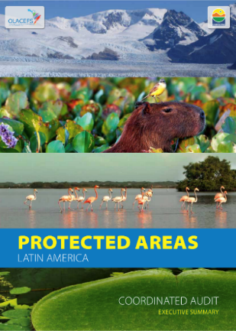
Source: TCU (link here). Source: TCU (link here).
Finally, follow-up of results can be performed individually by SAIs, and collectively through coordinated efforts, such as the above mentioned second edition of the coordinated audit on protected areas. As mentioned, 11 SAIs were able to compare the results of 2014 with the results of 2019 regarding 1,028 protected areas, thus being able to carry out an objective monitoring of how the public policies have unfolded since, what measures have been taken by governments, and whether SAIs’ recommendations have boosted the improvement of protected areas implementation and management.
Another tool used in this audit was the DFOG Analysis methodology, standing for analysis of duplication, fragmentation, overlap, and gap among public policies. Thereby, audit teams assessed possible blind spots and incoherencies between the protected areas public policy, the tourism public policy, and land-use public policies. This methodology was developed through adaptation and customization of FOD methodology, which was developed by SAI-USA, and first used in the coordinated audit on the preparedness of Latin American governments to implement the SDGs.
In a wider perspective, the INDIMAPA helps analysing local implementation of the protected areas public policy, whereas the DFOG Analysis allows to examine the relations between this policy and other related ones. Combining the results of both methodologies, the audit teams were able to assess the protected areas public policy from different and complementary angles.
In general, the results of the coordinated audit indicate a fair extent of contribution of the 17 participating countries to the percentages of Aichi Target 11, as well as an improvement of the level of implementation and management from 2014 to 2019. Regarding protected areas extension as a portion of the national territory, 13 countries (out of 17) had at least 17% of their land territory inside protected areas; as for marine and coastal zones, the 10% coverage was met by 9 countries—out of 14 that had marine jurisdiction and reported the corresponding data until 2020. This first audit finding does not imply the total fulfilment of Aichi Target 11, but rather the governments taking the first step in environmental governance of protected areas: their legal establishment.
As for implementation and management of protected areas, the INDIMAPA results show an improvement in efficacy of 1,028 protected areas evaluated both in 2014 and in 2019, in 11 countries. This upgrade was particularly observed in planning and management tools: the ability of engaging extra human and financial resources—nonetheless increasing the risk of being dependent and unsustainable—; implementation and appropriateness of management plans; planning of actions for environmental regulations enforcement; mechanisms for prioritisation of scientific research topics within protected areas; and existence and representativeness of committees for management and other participatory mechanisms. However, this upgrade from 2014 to 2019 does not dismiss measures for enhancement of such planning and management tools. Regarding the distribution of the 2,415 protected areas into the three ranks of INDIMAPA, results indicate that 16% of them (389) have a low level of implementation and management, 45% (1,086) presented a medium level, and 39% (940) had a high level. This second audit finding shows that a large group of protected areas present the minimum normative, institutional and operational conditions to function normally, thus being able to deliver preservation and conservation results—which does not guarantee these objectives are met. Overall, these conclusions suggest an ongoing improvement of the systems of protected areas of the participating countries.
The protected areas policies were also evaluated in tandem with other public policies: tourism and land-use planning, which relate to two important processes in protected areas—public use and territorial consolidation. In general, many opportunities were identified for better use of synergies and articulation among the ministries and government agencies responsible for these policies, especially for implementing ecotourism in a sustainable way—where possible—, and for integrating government actions for land management.
Due to the Covid-19 pandemic, the 2020-schedule of the coordinated audit was delayed, and, consequently, the audit findings and results are expected to be broadly released in early 2021, through a portfolio of communication products that are now being produced by the coordinator team, SAI-Brazil (see examples in Figures 1 and 2, above, and the previous paragraph).
In conclusion, coordinated audits constitute a valuable strategy to boost oversight over cross-border environmental issues, such as climate change mitigation and conservation of biodiversity through protected areas systems, and call for independent institutions such as SAIs in order to deliver independent, objective and reliable examination of the audit topic and a regional panorama with consolidated results. Moreover, coordinated audits provide the audit teams and stakeholders with capacity building, knowledge and experience sharing, tools for data collection and consolidation, and a joint assessment of public policies from different jurisdictions. It is important to stress that SAIs are at the core of independent follow-ups, assessments and evaluations of effectiveness, efficiency, economy, accountability, and transparency of public administration, considering national development objectives, international commitments and internationally agreed development goals, such as the SDGs, the Convention on Biodiversity Diversity (CDB), the Aichi Targets and the post-2020 targets, as well as other multilateral environmental frameworks.
More information about the audit process, methodology and phases can be found at some news that were released during the execution of the second edition of the coordinated audit on protected areas. In June 2020, a detailed article about the audit was published in the European Court of Auditors (ECA) Journal 02/2020: Climate Change and Audit (p. 106-111; link here). The work was also mentioned in Newsletters 2/2019 and 1/2020 (link here) of the Working Group on Environmental Auditing (WGEA) of the European Organisation of Supreme Audit Institutions (EUROSAI).

For more information about the International Organization of Supreme Audit Institutions (INTOSAI), please refer to https://www.intosai.org/
For the full documents, please refer to https://undocs.org/A/RES/66/209 and https://undocs.org/en/A/RES/69/228
INTOSAI Standards for Supreme Audit Institutions (ISSAI) 300: Performance Audit Principles, available in https://www.issai.org/pronouncements/issai-300-performance-audit-principles/
In Spanish: Comisión Técnica Especial de Medio Ambiente (COMTEMA) de la Organización Latinoamericana y del Caribe de Entidades Fiscalizadoras Superiores (OLACEFS). For more information, please refer to https://www.olacefs.com/medio-ambiente-comtema/
For more information on these audits, please refer to https://www.olacefs.com/auditorias-coordinadas/?lang=en
SAI-Brazil is the Brazilian Federal Court of Accounts (in Portuguese: Tribunal de Contas da União–TCU); for more information, please refer to https://portal.tcu.gov.br/en_us/english/
For the full Executive Summary of the first edition of the COMTEMA’s Coordinated Audit on Protected Areas, please refer to https://portal.tcu.gov.br/biblioteca-digital/auditoria-coordenada-nas-areas-protegidas-da-america-latina.htm
According to the audit, those results were achieved despite the lack of financial and human resources and deficiencies in the coordination of the system of protected areas. For more information about these findings, please refer to https://portal.tcu.gov.br/biblioteca-digital/auditoria-coordenada-em-unidades-de-conservacao-da-amazonia.htm Figures below show deforestation warnings (2008-2012) and carbon flow (1996-2006):
Argentina, Bolivia, Brazil, Chile, Colombia, Costa Rica, Cuba, El Salvador, Ecuador, Guatemala, Honduras, Mexico, Paraguay, Peru, Portugal, Spain, and the Dominican Republic.
For more information about the project, please refer to https://www.giz.de/en/worldwide/38305.html
For the full Executive Summary of the first edition of the COMTEMA’s Coordinated Audit on Protected Areas, please refer to https://portal.tcu.gov.br/biblioteca-digital/auditoria-coordenada-nas-areas-protegidas-da-america-latina.htm
SAI-USA is the United States Government Accountability Office (GAO), whose methodology and reports on fragmentation, overlap, and duplication can be found at https://www.gao.gov/duplication/overview
This audit was also coordinated by TCU, the SAI-Brazil, and for more information please refer to the communication products available in https://portal.tcu.gov.br/es/biblioteca-digital/coordinated-audit-on-the-preparedness-of-the-latin-american-governments-for-implementing-the-sustainable-development-goals.htm

